Database Design CS 6360

Project Phase II

**Team Member**

Yuchuan Liu 2021184144

Xian Shi 2021187621

Jiaming Fan 2021225346

Table of Contents

I. Updated EER Diagram 1

II. EER Diagram Update Log 2

III. Relation Schema 3

IV. Mapping Steps 4

V. Constrains of Relation Schema 6

# Updated EER Diagram

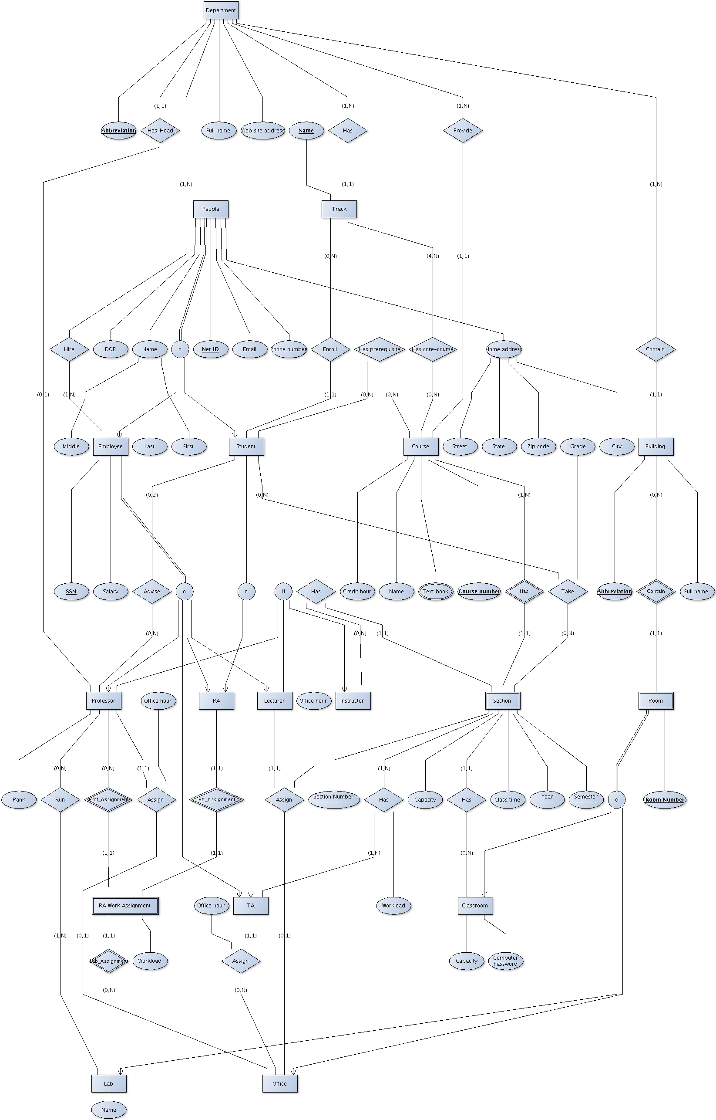

# EER Diagram Update Log

1. Remove entity type “Graduate School” and related relations. (The removal of entity type below will also remove related relation)
2. Change entity type “Room” to weak entity type and change relation type “Contain” among “Room” and “Building” to Identifying relationship type.
3. Remove entity type “Associate Prof.”, “Assistant Prof.”, and “Full Prof”, and add attribute “Rank” to entity type “Professor”.
4. Change the Specialization of entity type “Employee” to overlapping.
5. Change the partial key of weak entity type “Section” to combination of number, semester, and year. (Since the tool we choose doesn’t support partial key notation, we add “- - - - -“ beneath the attribute name)
6. Change the two minimal of cardinality constrains of relationship between entity types “Professor” and “Student” to 0.
7. Change cardinality constrains among entity type “RA”, “Professor”, “Lab”, and “RA Work Assignment”.
8. Change cardinality constrain for “Has Prerequisite” relation between entity type “Course” and “Student”. They are now partial participate.
9. Entity type “Instructor” becomes a union of “Lecturer” and “Professor”.
10. Entity type “Office” no longer has total participation in relationships “Assign” between “Lecturer”/”TA”/”Professor” and “Office”.
11. We change layout of EER model. Since previous version may cause difficulties in reading min-max constraints on edges.

# Relation Schema

INSTRUCTOR is a union of LECTURER and PROFESSOR. The primary key “net id” of INSTRUCTOR is foreign key refer to “net id” in thoes two relations. (We have two lines in diagram.)

RA/TA is both STUDENT and EMPLOYEE, The foreign key “net id” of TA/RA refer to STUDENT and EMPLOYEE at same time. (Due to complexity representing it in diagram, we just use two lines.)

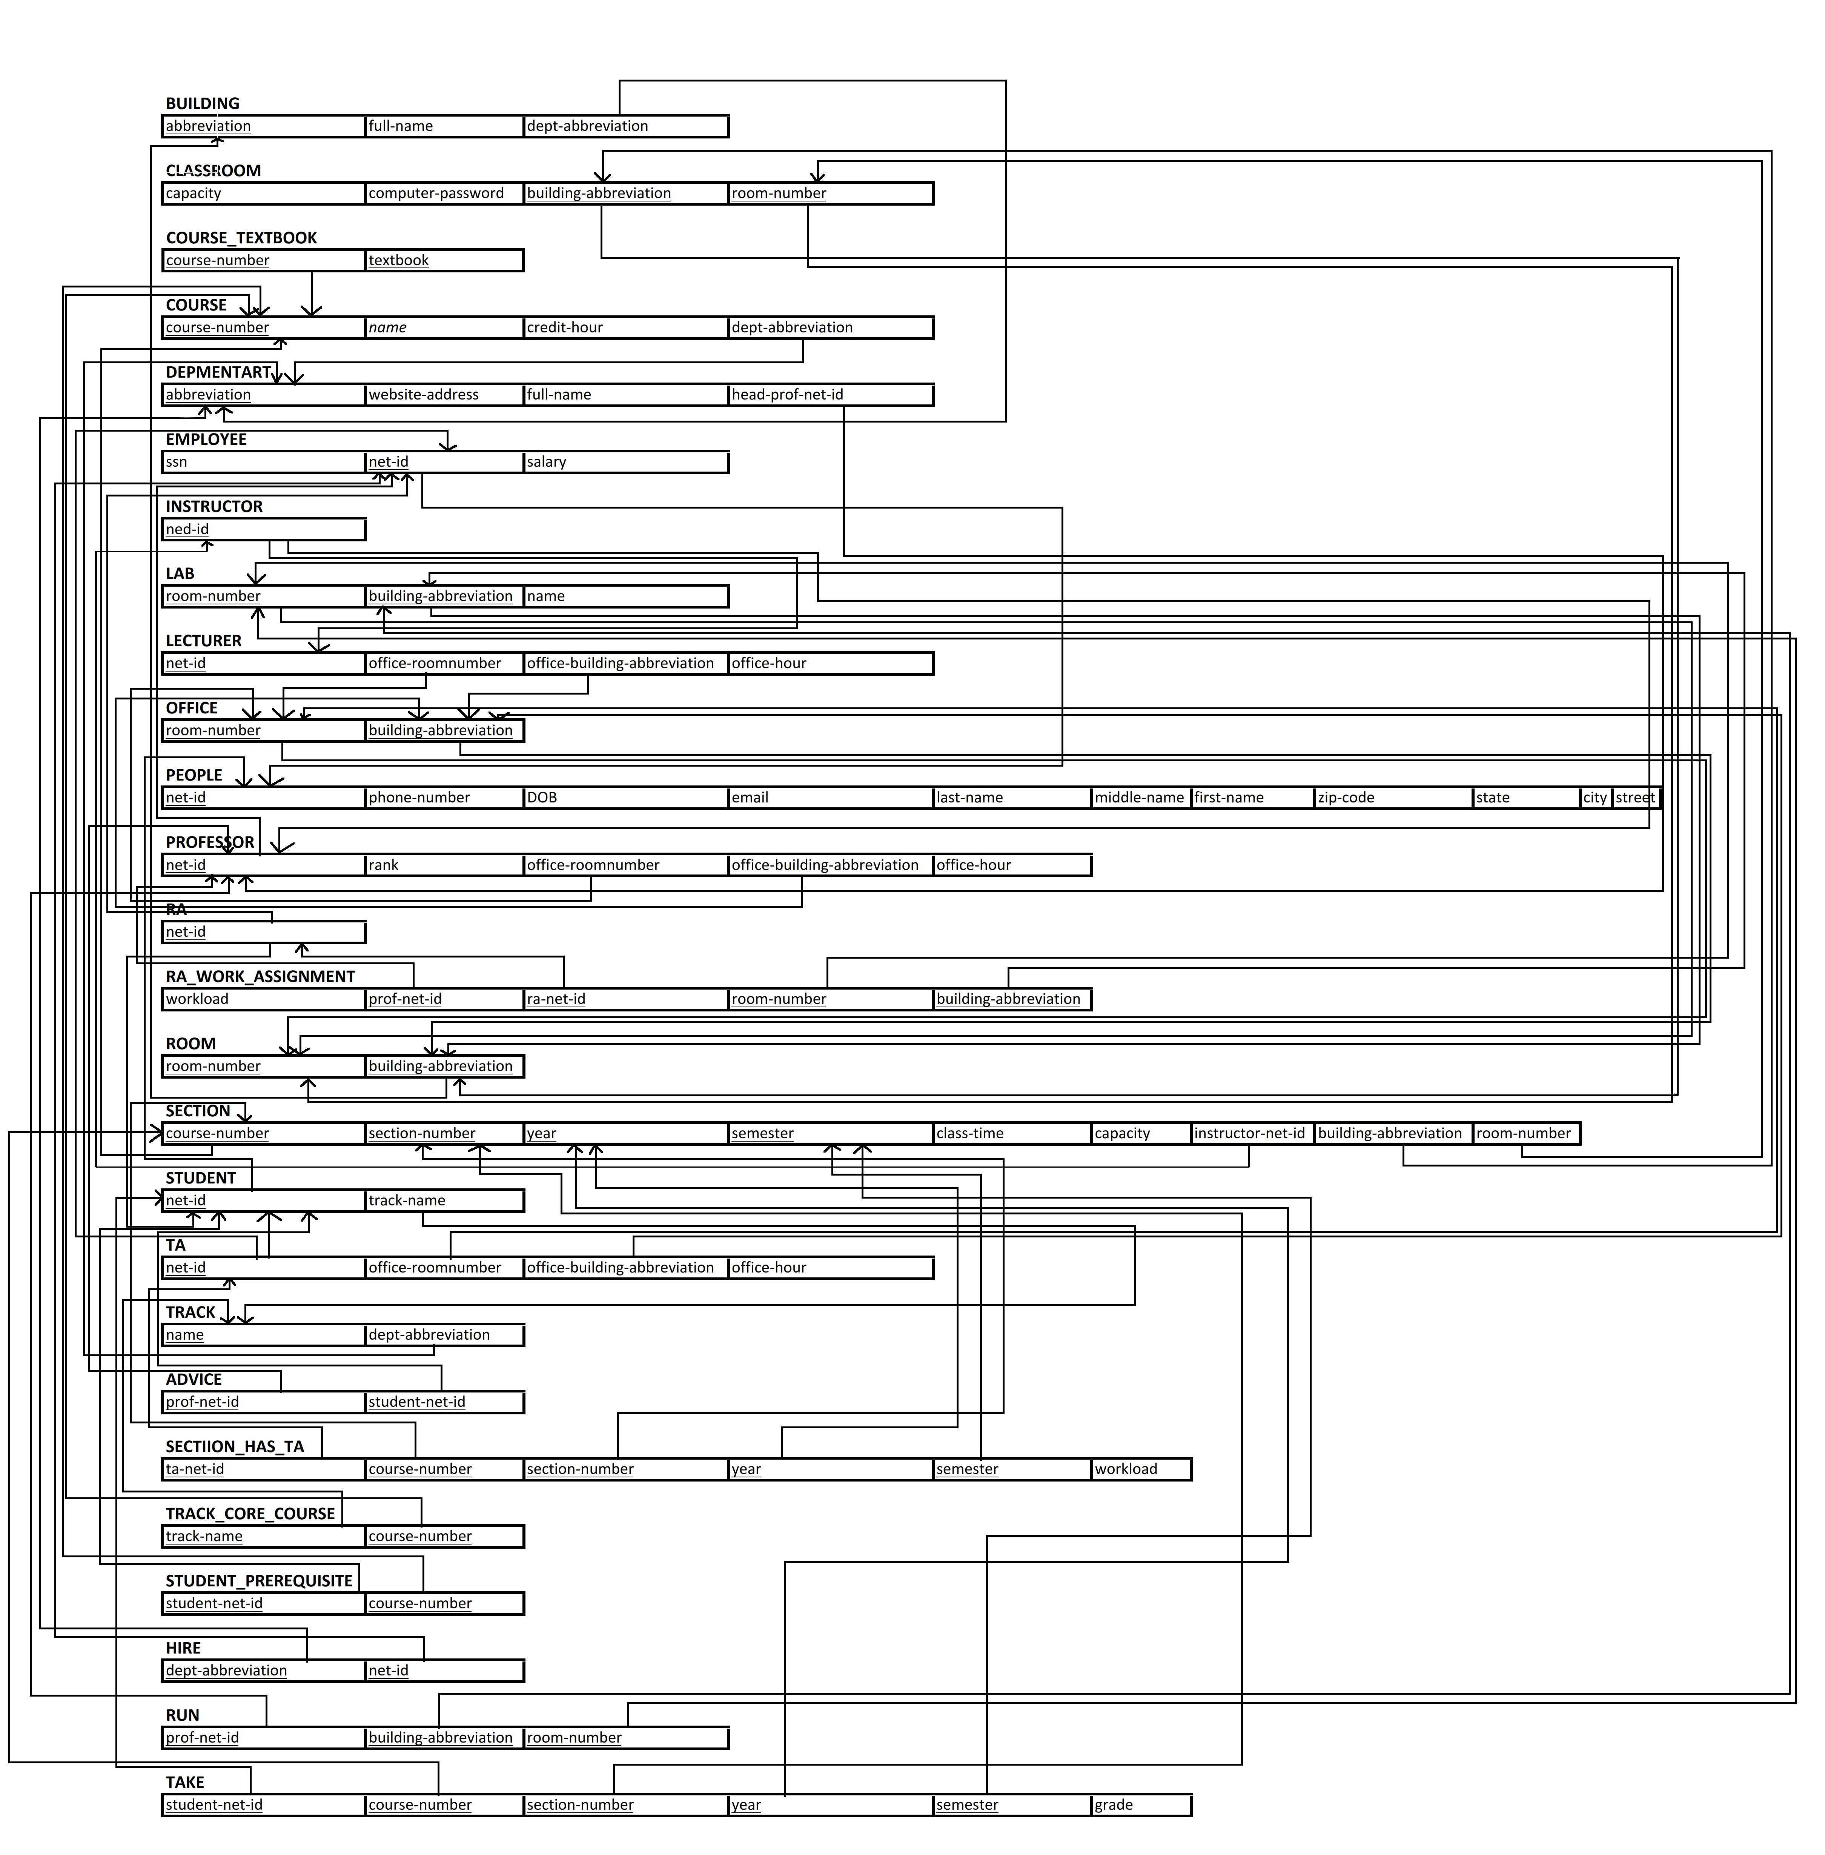

# Mapping Steps

We convert EER model to Relational Model based on following Steps:

* Map entity type “Building” to relation “BUILDING”. (Related attributes added as column header. Also apply to following if not specified)
* Map entity type “Classroom: to relation “CLASSROOM”. We use Option 8A, multiple relations with superclass and subclasses. We choice this option for all rest superclass and subclasses, if not specified.
* Map entity type “Course” to relation “COURSE”.
* Map multi-value attribute textbook and attribute course-number of entity type “COURSE” to relation “COURSE_TEXTBOOK”.
* Map entity type “Department” to relation “Department”.
* Map entity type “Employee” to relation “EMPLOYEE”.
* Map entity type “Instructor” to relation “INSTRUCTOR”. It is a Union of Professor and Lecturer. We use their common key “net-id” as INSTRUCTOR's key.
* Map entity type “lab” to relation “LAB”.
* Map entity type “Lecturer” to relation “LECTURER”.
* Map entity type “Office” to relation “OFFICE”.
* Map entity type “People” to relation “PEOPLE”.
* Map entity type “Professor” to relation “PROFESSOR”.
* Map entity type “RA” to relation “RA”.
* Map entity type “RA Work Assignment” to relation “RA_WORK_ASSIGNMENT”.
* Map entity type “Room” to relation “ROOM”.
* Map entity type “Section” to relation “SECTION”.
* Map entity type “Student” to relation “STUDENT”.
* Map entity type “TA” to relation “TA”.
* Map entity type “Track” to relation “TRACK”.
* Map relationship type “Advice” between Student and Professor to relation “ADVICE”.
* Map relationship type “Assign” between Professor and Office as attributes to relation “PROFESSOR”. (We put OFFICE’s Key as attributes to relation PROFESSOR. We will do similar below when we map relationship type as attributes.)
* Map relationship type “Assign” between Lecturer and Office as attributes to relation “LECTURER”.
* Map relationship type “Assign” between TA and Office as attributes to relation “TA”.
* Map relationship type “Contain” between Department and Building as attributes to relation “BUILDING”.
* Map relationship type “Enroll” between Track and Student as attributes to relation “STUDENT”.
* Map relationship type “Has” between Instructor and Section as attributes to relation “SECTION”.
* Map relationship type “Has” between Section and TA to relation “SECTION_HAS_TA”.
* Map relationship type “Has” between Section and Classroom as attributes to relation “SECTION”.
* Map relationship type “Has” between Department and Track as attributes to relation “TRACK”.
* Map relationship type “Has core-course” between Track and Course to relation “TRACK_CORE_COURSE”.
* Map relationship type “Has prerequisite” between Student and Course to relation “STUDENT_PREREQUISITE”.
* Map relationship type “Has Head” between Department and Professor as attributes to relation “DEPARTMENT”.
* Map relationship type “Hire” between Department and Professor to relation “HIRE”.
* Map relationship type “Provide” between Department and Course as attributes to relation “COURSE”.
* Map relationship type “Run” between Professor and Lab to relation “RUN”.
* Map relationship type “Take” between Student and Section to relation “TAKE”.

# Constrains of Relation Schema

There is only one candidate key for our relation schema. “ssn” could be candidate key for relation “EMPLOYEE”. However, we choose “net id” as its primary key since all other people related relations use “net id” as primary key.

We have following diagram for our constraints on relation schema. The constraint for attribute is right beneath.

Macintosh HD:Users:leoyuchuan:Desktop:Temp DB Project:Database Relational Schema Constrain V1.2.pdf